Name: Rasha Mansour

ID:1210773

**7.6 Post Lab**

1. Design a 4x16 RAM using four 4x4 RAMS.

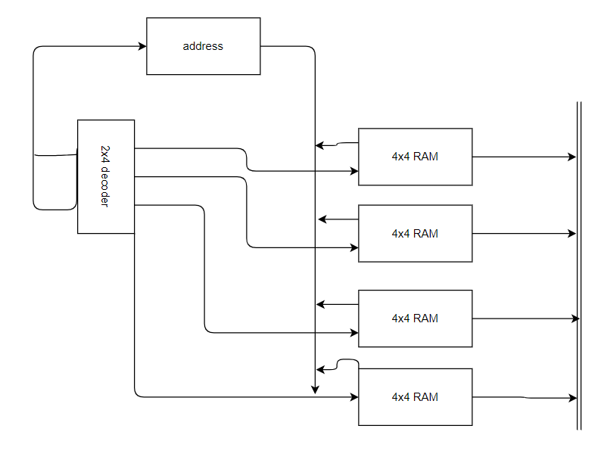

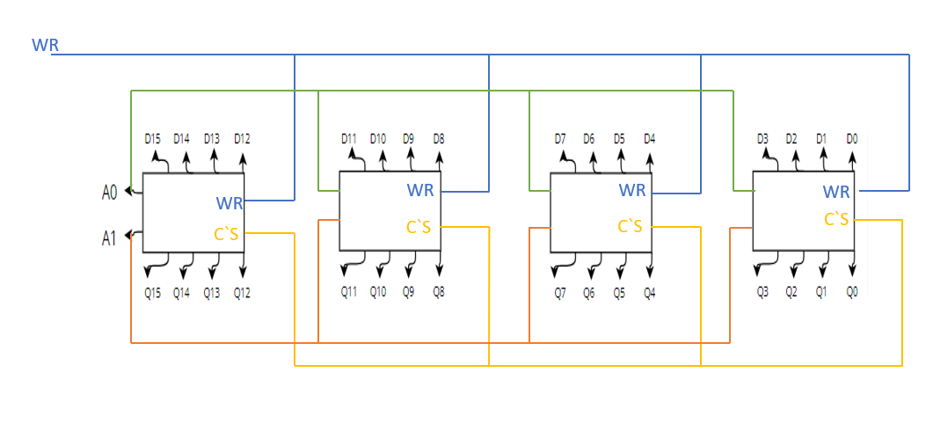

2. Although D latches are useful for storing binary information, they are not used in RAM circuit design,

why?

Latches are level sensitive, the input has an effect on the output whenever the clock is in the high position, when the hour hand is high on the clock, this occurs again, the value is not being stored, rather it is constantly shifting in a new direction, as a result, flip-flops that are sensitive to edges are the ones that are recommended for use in memory elements. There is a possibility that the latches will store incorrect values. If there is a feedback loop present in the circuit. Latches could also cause a race condition to develop.